Material classes and atomic bonding

Question 1: The higher the bond energy in a material, ...

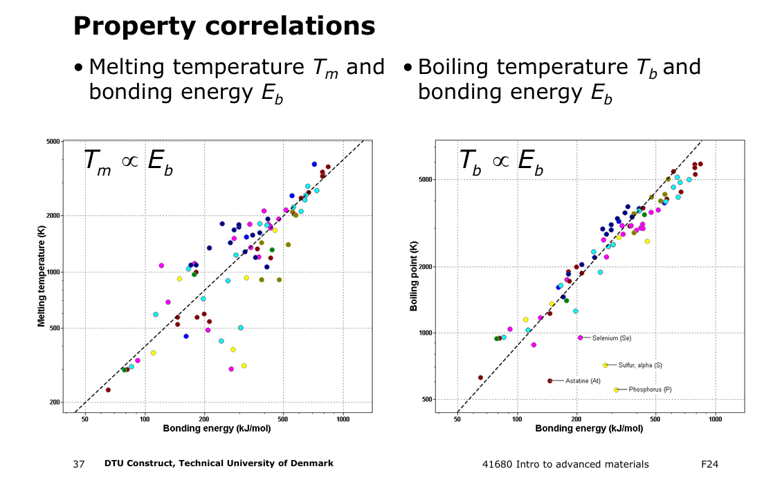

* …the higher the molar mass
* **…the higher its melting temperature.**
* … the higher its thermal expansion coefficient.
* … the higher its electrical resistance.

Question 2: Which of the four metals has the highest thermal expansion coefficient?

Mercury is known to be liquid at room temperature unlike the others, and a liquid has a lower bonding energy than a solid. Thus, mercury has the highest thermal exp coeff.

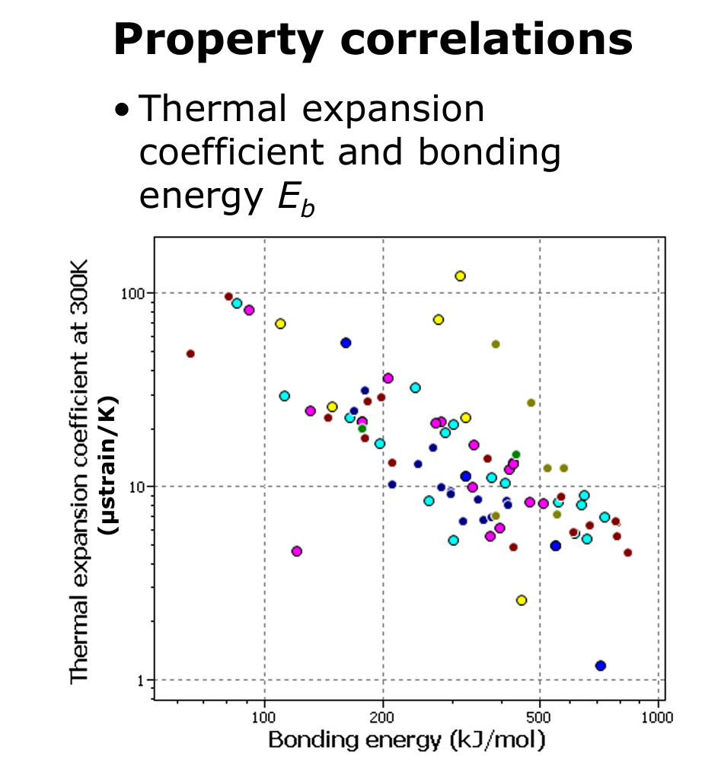

* **Hg**
* Al
* Ag
* Ta

Question 3: Free electrons in metallic bonding make metals…

* **Opaque**
* Brittle
* Thermal insulating
* Ferro-magnetic

Question 4: Electron pair bonding causes…

* … a high electrical conductivity.
* **… a high heat conductivity.**
* … a low melting temperature.
* … a high thermal expansion coefficient.

Question 5: Which type of bonding is not relevant for polymers?

* Covalent bonds
* Hydrogen bonds
* **Metallic bonds**
* Van der Waals forces

Question 6: Which of the three chemical compounds $PtO$, $Y_{2}S_{3}$, or $Ca_{2}Cl$ has the highest fraction of covalent bonding?

By this statement, those f*ckers apparently mean “which of the three has a higher covalent bonding fraction than ionic bonding fraction)

$$f_{ion}=1-e^{\frac{-{\left(x_{A}-x_{B}\right)}^{2}}{4}} ⟺f_{cov}=e^{\frac{-{\left(x_{A}-x_{B}\right)}^{2}}{4}}$$

$$f_{cov}\left(PtO\right)=e^{\frac{-{\left(2,2-3,44\right)}^{2}}{4}}≈0,680859$$

$$f_{cov}\left(Y_{2}S_{3}\right)=e^{\frac{-{\left(1,22-2,58\right)}^{2}}{4}}≈0,6297704$$

$$f_{cov}\left(Y_{2}S_{3}\right)=e^{\frac{-{\left(1,00-3,16\right)}^{2}}{4}}≈0,3114863$$

$PtO$

$Y_{2}S_{3}$

$Ca_{2}Cl$

* **There are two compounds with highest fraction of covalent bonding.**

Question 7: Which combination of the three elements $Cr$, $Nb$, and $N$ leads to a compound with largest fraction of metallic bonding?

Nitrogen is NOT a metal…

* **Cr and Nb**
* Cr and N
* Nb and N
* Cr, Nb and N

Question 8: Which statement about rock salt (NaCl) is correct?

$$Na→Na^{+}+e$$

$$Cl+e→Cl^{-}$$

* Sodium atoms receive an extra electron.
* Sodium ions release one of their electrons.
* **Chlorine atoms receive an extra electron.**
* Chloride ions release one of their electrons.

Question 9: Which chemical formula gives a proper description for a ceramic material?

Ceramics are NOT composed of ions, therefore must have neutral valence.

Oxide: $O^{2-}$

Aluminium ion: $Al^{3+}$

Chloride: $Cl^{-}$

$Al_{2}Cl_{3}$

$2·3-3·1=3$

$AlCl$

$1·3-1·1=2$

$Al_{2}O_{3}$

$2·3-3·2=0$

$AlO_{2}$

$1·3-2·2=-1$

Question 10: Why is the boiling point of potassium (K) higher than that of krypton (Kr)?

* Kr has a lower molar mass than K.
* Kr has a higher molar mass than K.
* Kr has more free valence electrons than K.
* **Kr has less free valence electrons than K.**

Crystallography

Question 1: Which is the proper notation for crystallographic equivalent directions?

Specific direction [ ]

Specific plane ( )

All equivalent directions: < >

All equivalent planes: { }

$[uvw]$

$<uvw>$

$|uvw|$

$\{uvw\}$

Question 2: Which crystallographic direction is shown in the figure?

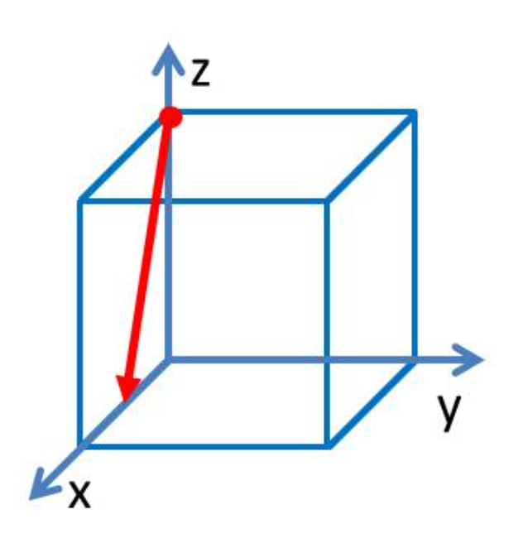

$1/2$ in $x$ direction, $0$ in $y$ direction, $-1$ in $z$ direction

$$\left[\frac{1}{2},0,-1\right]·2=\left[1,0,\overline{2}\right]$$

$[10\overline{2}]$

$[\overline{1}02]$

$[\overline{2}01]$

$[20\overline{1}]$

Question 3: Which crystallographic direction is shown in the figure?

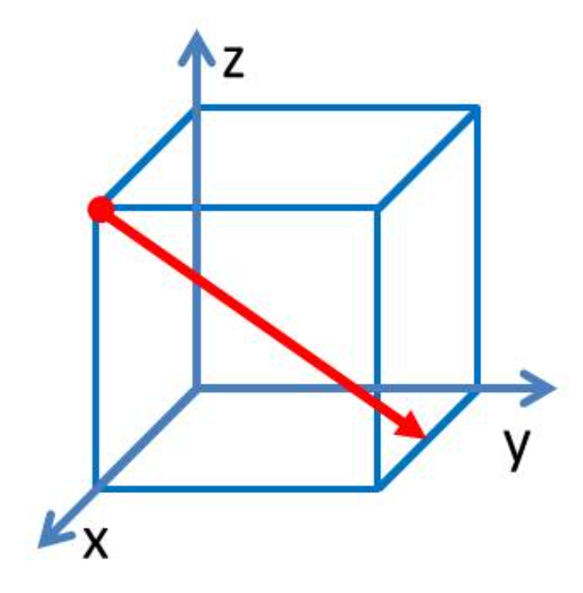

$-1/2$ in $x$ direction, $1$ in $y$ direction, $-1$ in $z$ direction

$$\left[-\frac{1}{2},1,-1\right]·2=\left[\overline{1},2,\overline{2}\right]$$

$[122]$

$[1\overline{2}2]$

$[\overline{1}2\overline{2}]$

$[\overline{1}\overline{2}\overline{2}]$

Question 4: What is shown red in the figure?

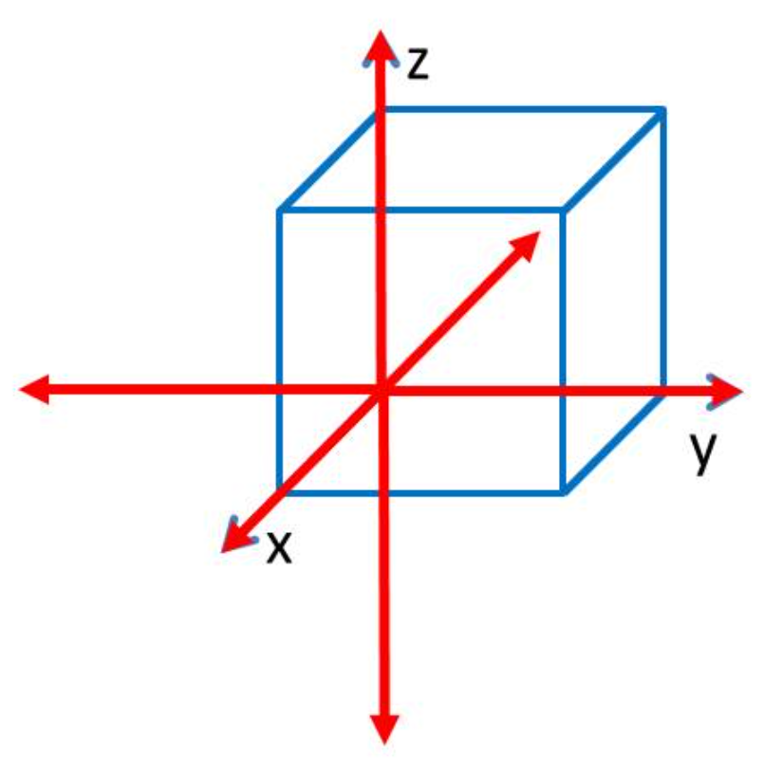

The figure obviously shows all perpendicular equivalents of $[100]$, i.e., $<100>$.

* all $[100]$ directions
* some $[100]$ and some $[\overline{1}00]$ directions
* **all $<100>$ directions**
* some $<010>$ directions

Question 5: Which of the four figures does not show a {110} plane?

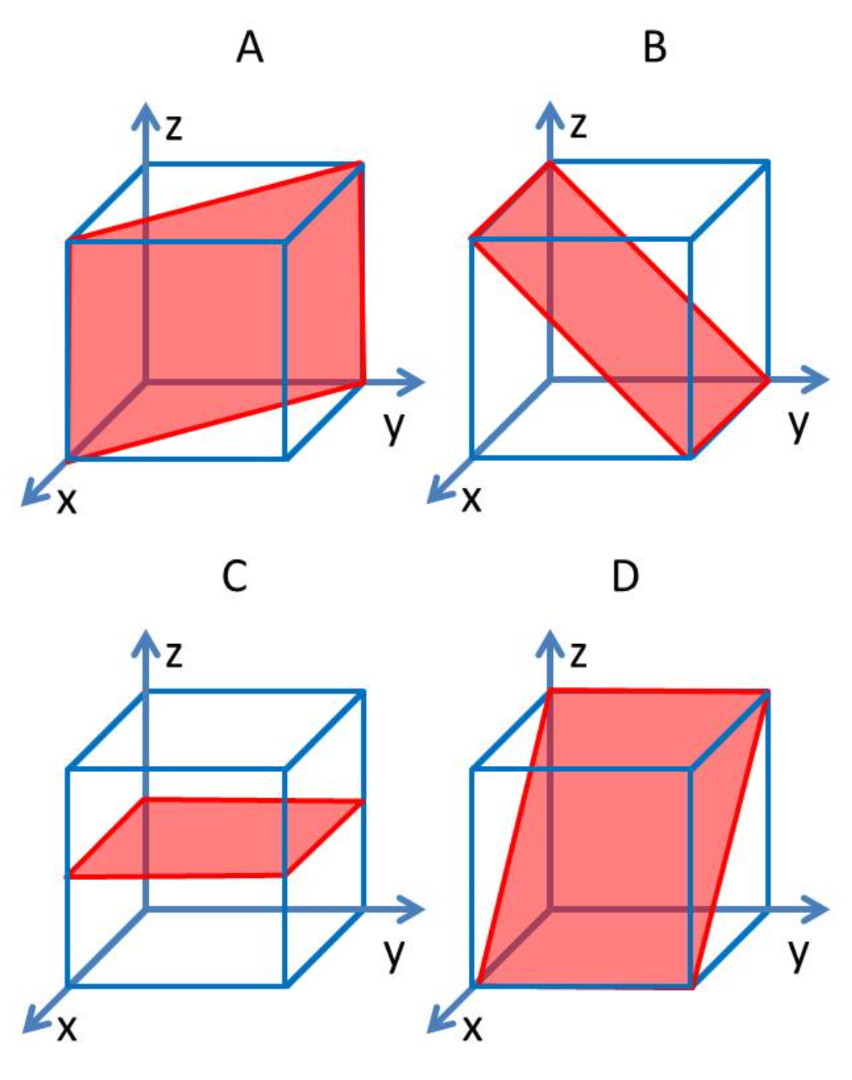

C is a (020) plane, so it is a {100} plane, which is NOT a {110} plane.

* A
* B
* **C**
* D

Question 6: What are the proper Miller indices for the plane shown in the figure?

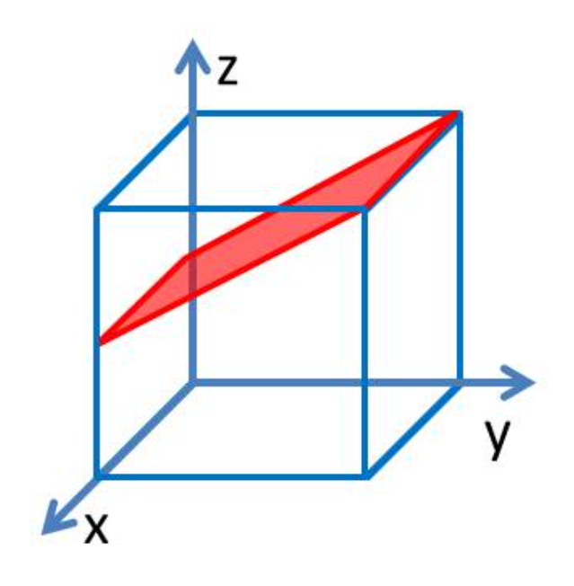

Infinite on $x$ axis, $1$ on $y$ axis, $-\frac{1}{2}$ on $z$ axis.

$$\left(h:k:l\right)=(\frac{1}{m}:\frac{1}{n}:\frac{1}{p})$$

$$\left(m:n:p\right)=\left(∞,1,-\frac{1}{2}\right)→\left(h:k:l\right)=\left(0,1,\overline{2}\right)$$

$(012)$

$(021)$

$(02\overline{1})$

$\left(01\overline{2}\right)$

Question 7: What are the proper Miller indices for the plane shown in the figure?

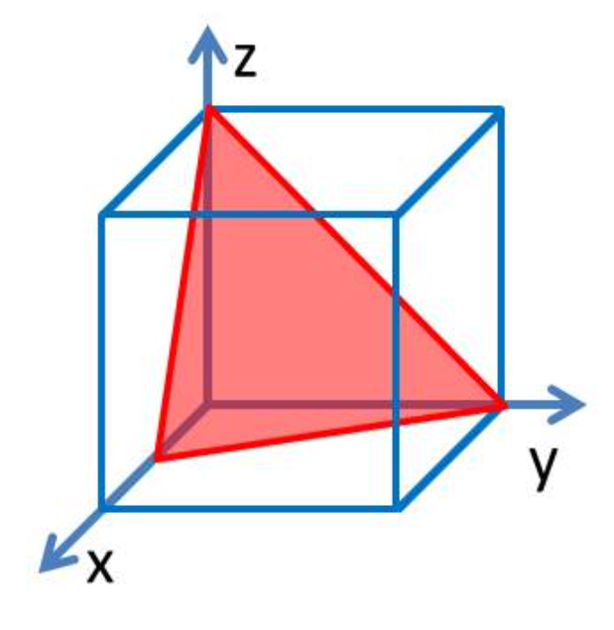

$1/2$ on $x$-axis, $1$ on $y$-axis, $1$ on $z$-axis

$$\left(h:k:l\right)=(\frac{1}{m}:\frac{1}{n}:\frac{1}{p})$$

$$\left(m:n:p\right)=\left(\frac{1}{2},1, 1\right)→\left(h:k:l\right)=\left(2,1,1\right)$$

$(112)$

$(211)$

$(221)$

$(122)$

Question 8: The figure shows the unit cell of the diamond structure.

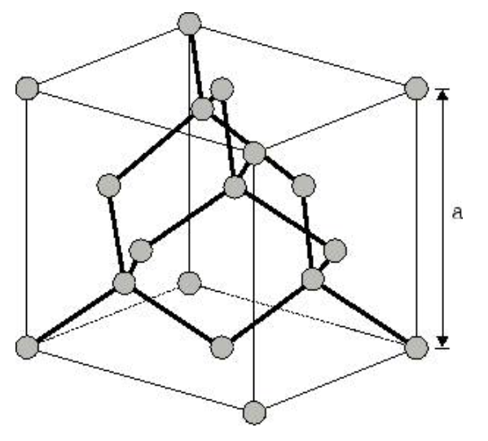

What is the coordination number in the lattice?

Each atom obviously has 4 neighbors.

* **4**
* 6
* 8
* 12

Question 9: The figure shows the unit cell of the diamond structure.

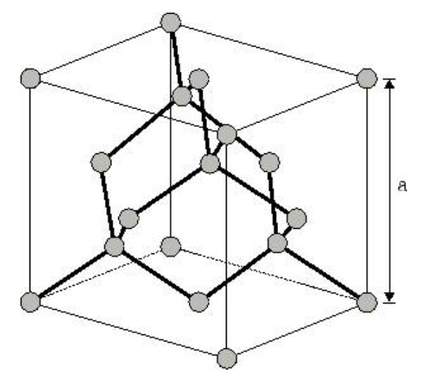

How many atoms belong to the unit cell?

Corner atoms (8) are shared between 8 unit cells.

Face centered atoms (6) are shared between 2 unit cells:

$$18-\left(8-\frac{8}{8}\right)-\left(6-\frac{6}{2}\right)=8$$

* **8**
* 12
* 16
* 18

Question 10: The figure shows the unit cell of the diamond structure.



Which planes are packed closest in the lattice?

The closest packed plane for a diamond structure is $\{111\}$.

$\{100\}$

$\{110\}$

$\left\{111\right\}$

* None of the mentioned

Lattice defects

Question 1: Which lattice defects can be found in pure aluminium at room temperature?

* Vacancies and substitutional atoms
* Vacancies and particles
* **Dislocations and grain boundaries**
* Dislocations and phase boundaries

Question 2: Which defects cannot be removed completely from crystalline materials?

* **Vacancies**
* Dislocations
* Grain boundaries
* Pores

Question 3: Which crystalline lattice has the largest interstitial sites compared to the size of the constituting atoms?

The simple cubic lattice is the LEAST packed of the three provided lattices. Therefore, it has room for a larger interstitial site.

* **The simple cubic lattice**
* The face centererd cubic lattice
* The body centered cubic lattice
* There is no difference between the relative sizes of the interstitial sites of all three lattices

Question 4: Which type of defect separates a twin from its matrix?

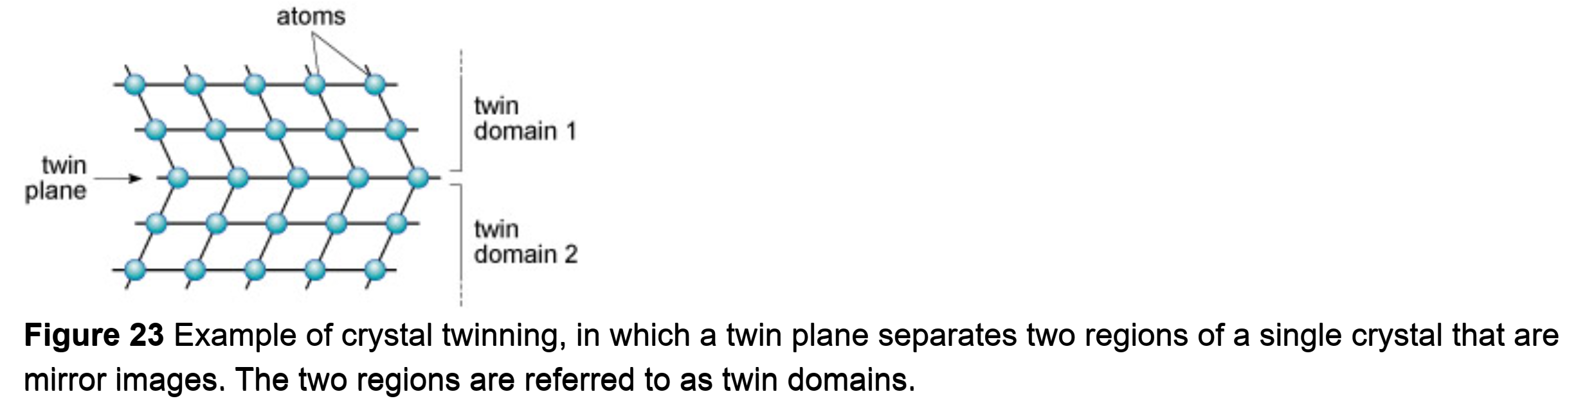

* A zero-dimensional defect
* A one-dimensional defect
* **A two-dimensional defect**
* A three-dimensional defect

Question 5: Compare two specimens of pure Au with different grains sizes: specimen A is coarse grained with an average grain size of 50 µm, specimen B is nanocrystalline with an average grain size of 100 nm. Which statement is correct?

More grain boundaries = higher defect density, but also stronger and tougher

* **A has a lower defect density than B.**
* A has the same defect density as B.
* A has a higher defect density than B.
* Neither A

Question 6: Water is heated in an aluminium kettle from room temperature 25 °C. How has the vacancy concentration in the kettle material changed, when the water is boiling? The vacancy formation energy in aluminium is 0.66 eV.

$$C_{V}=\frac{N_{V}}{N}=e^{\frac{-Q_{V}}{kT}}$$

$$k=1,38·{10}^{-23}\frac{J}{K}$$

$$1 eV=1,602·{10}^{-19}J$$

$$Q_{V}=0,66 eV·\left(1,602·{10}^{-19}\frac{J}{eV} \right)=1,05732·{10}^{-19} J$$

$$\frac{C_{V}\left(room\right)}{C_{V}\left(boil\right)}=\frac{e^{\frac{1,05732·{10}^{-19} J}{1,38·{10}^{-23}\frac{J}{K}·298,15 K}}}{e^{\frac{1,05732·{10}^{-19} J}{1,38·{10}^{-23}\frac{J}{K}·373,15 K}}}=175,0375393139661≈175$$

* It increased by a factor of 4.
* **It increased by a factor of 175.**
* It increased by a factor of ${10}^{4}$.
* It increased to ${10}^{-4}$.

Question 7: Complete solubility of two elements does NOT require…

Hume-Rothery rules for substitutional solubility must be satisfied:

* + - Difference in radii must be less than $±15\%$
    - Crystal structures must be the same
    - The electronegativities must be similar
    - The valences should be the same.

So, it DOES require similar valence, crystal structure and lattice constant (related to radii). But does NOT require similar electrical conductivity.

* **… similar electrical conductivity.**
* … similar lattice constant.
* … similar valence.
* … similar crystal structure.

Question 8: The lattice constant of a solid solution of B atoms in A…

This is function of the composition, i.e., depends on the respective lattice constants of the atoms and the fractions of each type.

* … is always smaller than the lattice constant of pure A.
* … is equal to the lattice constant of pure A.
* … is always larger than the lattice constant of pure A.
* **… depends linearly on the composition.**

Question 9: Polonium has an atomic mass of 210 g/mol and an atomic radius of 168 pm. It forms a simple cubic lattice at low temperatures. What is its mass density?

$${10}^{-7}\frac{cm}{nm}$$

$$R_{at}= 168 pm·\frac{{10}^{-10}cm}{pm}=1,68·{10}^{-8} cm$$

$$m_{at}=\frac{M_{at}}{N_{A}}=\frac{210\frac{g}{mol}}{6,022·{10}^{23} mol^{-1}}=3,487213550315511·{10}^{-22} g$$

$$ρ_{theo}=\frac{m_{at}}{\frac{4π}{3}·R_{at}^{3}}=\frac{3,487213550315511·{10}^{-22} g}{\frac{4·π}{3}·{\left(1,68·{10}^{-8} cm\right)}^{3}}≈17,55748 \frac{g}{cm}$$

$$ρ=APF\left(SC\right)·ρ_{theo}=17,55748 \frac{g}{cm}·52\% ≈9,12989 \frac{g}{cm^{3}}$$

* Less than $8.9 g/cm^{3}$
* **About $9.2 g/cm^{3}$**
* About $12.0 g/cm^{3}$
* More than $12.5 g/cm^{3}$

Question 10: Copper has a lower mass density than gold, because…

$$M\left(Cu\right)=63,546 g/mol$$

$$M\left(Au\right)=196,9665\frac{g}{mol}$$

They have the same crystal structure, FCC.

* … Cu has a higher electronegativity than Au.
* … Cu atoms are larger than Au atoms.
* **… Cu atoms have a lower mass than Au atoms.**
* … Cu has a different crystal structure than Au.

Mechanical testing

Question 1: Which of the following conditions is required for a deformation to be elastic?

The definition of elastic deformation is that it is REVERSIBLE, while plastic deformation is mostly PERMANENT.

* Elastic strain must depend linearly on applied stress.
* Elastic strain must disappear during unloading.
* Elastic strain must occur instantaneously.
* **Elastic strain must be completely reversible.**

Question 2: Elastic moduli do NOT depend on…

It DOES depend on temperature, chemical composition and crystallographic direction (anisotropy), but NOT specimen shape (since initial cross sectional area and length is taken account for)

* Test temperature.
* Chemical composition.
* **Specimen shape.**
* Crystallographic direction.

Question 3: Which Poisson ratio describes volume conservation?

$$v=\frac{-Δd/d_{0}}{ΔL/L_{0}}=\frac{-ϵ_{x}}{ϵ_{z}}$$

Volume conservation: $v=0,5$

* 1
* **0.5**
* 0
* -0.5

Question 4: Young’s modulus depends commonly on th crystallographic direction in the following manner:

Anisotropy (usually):

$$E_{<111>}>E_{<110>}>E_{<100>}$$

$E_{[100]}>E_{[001]}$

$E_{[100]}>E_{[111]}$

$E_{[100]}>E_{[001]}$

$E_{[100]}<E_{[111]}$

Question 5: Young’s modulus of a material with pores is… that of the same material without pores?

Pores make a material LESS stiff and more vulnerable to stretch.

* … exactly the same as …
* … larger than …
* **… smaller than …**
* … not related to …

Question 6: Which parameter must be maximized for obtaining a light and stiff rod?

For a STIFF rod, we want a BIG Young’s modulus $E$. For a LIGHT rod, we want a LOW density $ρ$. Therefore, we want to maximize $E/ρ$.

$E$

$E/ρ$

$E/ρ^{2}$

$ρ/E$

Question 7: How can one assess the parameter $E/ρ$?

The speed of sound in a solid is determined by the density and elasticity of the material. Therefore, the Young’s modulus and density can apparently be determined by “dropping it and listening”. Weird right?

* By weighing it and measuring its cross section.
* By loading it with a force and measuring the elongation.
* By applying a voltage and measuring the electrical current.
* **By dropping it and listening.**

Question 8: A test specimen with geometry shown in the figure is pulled to failure with a tensile test apparatus. The size of the specimen before and after the test is shown. The graph below shows the force as function of the elongation as recorded by the tensile test equipment.

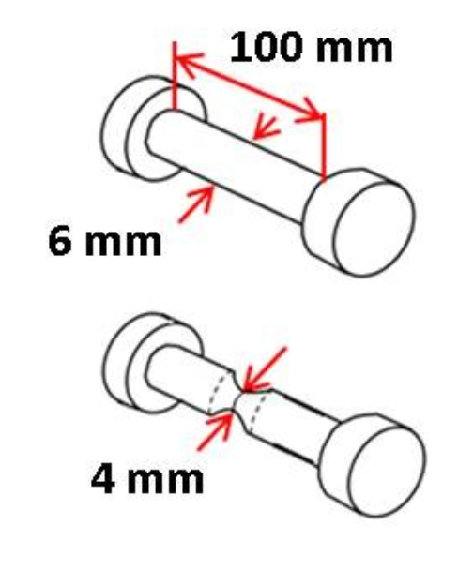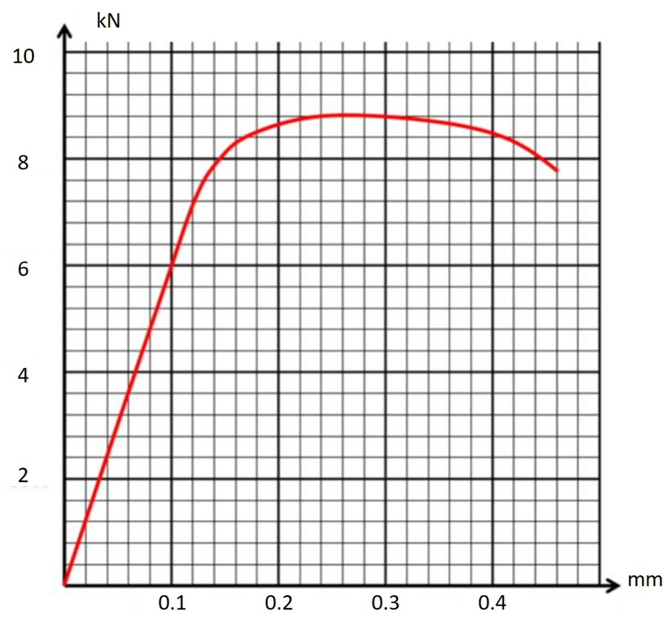

Young’s modulus is…

We pick a point on the elastic (linear) part of the stress curve $(0.1 mm; 6 kN)$.

Then, from here we calculate the stress and strain by $σ=F/A_{0}$ and $ϵ=ΔL/L_{0}$:

$$F=6 kN=6000 N$$

$$D_{0}=6 mm=0,006 m$$

$$A_{0}=π{\left(\frac{D_{0}}{2}\right)}^{2}=π{\left(\frac{0,006 m}{2}\right)}^{2}≈2,827433·{10}^{-5} m^{2}$$

$$L_{0}=100 mm=0,1 m$$

$$ΔL=0,1 mm=0,0001 m$$

$σ=\frac{F}{A_{0}}=\frac{6000 N}{2,827433·{10}^{-5} m^{2}}≈2,122066·{10}^{8} Pa$

$$ϵ=\frac{ΔL}{L_{0}}=\frac{0,0001 m}{0,1 m}=0,001$$

At last, we compote the Young’s modulus by $E=σ/ϵ$

$$E=\frac{σ}{ϵ}=\frac{2,122066·{10}^{8} Pa}{0,001}≈2,122066·{10}^{11} Pa≈212 GPa$$

* less than 200 MPa.
* between 200 MPa and 220 MPa.
* **between 200 GPa and 220 GPa.**
* larger than 220 GPa.

Question 9: A test specimen with geometry shown in the figure is pulled to failure with a tensile test apparatus. The size of the specimen before and after the test is shown. The graph below shows the force as function of the elongation as recorded by the tensile test equipment.



The tensile strength is…

The UTS is at the peak of the curve $(0.25 mm;8.8 kN)$.

Then, from here we calculate the stress by $σ=F/A_{0}$:

$$F=8.8 kN=8800 N$$

$$D_{0}=6 mm=0,006 m$$

$$A_{0}=π{\left(\frac{D_{0}}{2}\right)}^{2}=π{\left(\frac{0,006 m}{2}\right)}^{2}≈2,827433·{10}^{-5} m^{2}$$

$$σ=\frac{F}{A_{0}}=\frac{8800 N}{2,827433·{10}^{-5} m^{2}}≈3,112364·{10}^{8} Pa≈310 MPa$$

* about 210 MPa.
* about 255 Mpa.
* about 275 MPa.
* **about 310 Mpa.**

Question 10: A test specimen with geometry shown in the figure is pulled to failure with a tensile test apparatus. The size of the specimen before and after the test is shown. The graph below shows the force as function of the elongation as recorded by the tensile test equipment.



The ductility is…

The ductility is the strain at which the specimen fractures. The point of fracture is clearly $(0.52 mm;7.8 kN)$.

Then, from here we calculate the strain $ϵ=ΔL/L_{0}$:

$$L_{0}=100 mm=0,1 m$$

$$ΔL=0,52 mm=0,00052 m$$

$$ϵ=\frac{ΔL}{L_{0}}=\frac{0,00052 m}{0,1 m}=0,0052=0,52\%$$

* **less than 1%.**
* larger than 10%.
* about 2.5 MPa.
* about 275 MPa.

Plastic deformation and strengthening

Question 1: Which point defects will NOT increase strength?

Vacancies do NOT make a material stronger. If anything, they make it weaker (less tough) at large enough amounts.

* **Vacancies**
* Interstitial atoms
* Small substitutional atoms
* Large substitutional atoms

Question 2: What is the microstructural reason for work-hardening?:

Work hardening works by creating dislocations in the specimen, thus strengthening it.

* A reduction in dislocation density
* A reduction in grain size
* **An increase in dislocation density**
* An increase in grain size

Question 3: The strength of a pure metal can be changed by solution of foreign atoms or plastic deformation. The largest strength is achieved...

Both alloying with foreign atoms of stronger yield strength and plastic deformation cause a higher yield strength in the material!

* … by alloying with foreign atoms (without deformation).
* … by plastic deformation (without foreign atoms).
* **… by application of both (alloying and plastic deformation).**
* … without applying any treatment (i.e., neither alloying nor plastic deformation)

Question 4: Reducing the grain size in a material will…

Reducing the grain size, will create more grain boundaries, hindering dislocation and preventing fracture. Thus, both strength and toughness will increase.

* … reduce both, its strength and toughness.
* … reduce its strength, but increase its toughness.
* **… increase both, its strength and toughness.**
* … increase its strength, but decrease its toughness.

Quesition 5: The flow stress of a metal depends linearly on…

Flow stress is the same as yield strength $σ_{y}$.

Work-hardening:

$$σ=σ_{0}+Δσ_{disl}=σ_{0}+MaGb\sqrt{ρ}$$

* … the dislocation density.
* **… the square root of the dislocation density.**
* … the inverse of the dislocation density.
* … the inverse of the square root of the dislocation density.

Question 6: Two vanadium specimens have yield stresses of 530 MPa and 188 MPa due to their different grain sizes of 1 µm and 100 µm respectively. What is the Hall Petch coefficient of vanadium?

Grain refinement:

$$σ=σ_{0}+Δσ_{gb}=σ_{0}+\frac{k_{y}}{\sqrt{D}}$$

Let’s solve two equations of two unknowns:

$$530 MPa=σ_{0}+\frac{k_{y}}{\sqrt{1 μm}}$$

$$188 MPa=σ_{0}+\frac{k_{y}}{\sqrt{100 μm}}$$

$⇕$*Ligningssystemet løses for σ_0,k_y vha. WordMat's 'Løs Ligninger' funktion,*



$$σ_{0}=150·MPa ∧ k_{y}=380·MPa·μm^{0,5}$$

$91 MPa$ $μm$

$91 Mpa μm^(1/2)$

$380 Mpa μm$

$380 MPa μm^(1/2)$

Question 7: Which measure cannot be quantified in MPa?

The Young’s $(E=\frac{σ}{ϵ})$ modulus is measured in Pa, since $σ$ is also in Pa and $ϵ$ is dimensionless.

Tensile strength $σ_{UTS}$ is also a point of stress $σ$ and measured in Pa.

The ductility $(ϵ^{*})$ is the strain at which the specimen fractures. It has NO dimension.

Resilience $R=\frac{{\left(σ_{y}\right)}^{2}}{2E}$ is area under elastic part of stress-strain curve and is measured in Pa.

* Young’s modulus
* Tensile strength
* **Ductility**
* Resilience

Question 8: A and B are completely miscible. Which statement about AB alloys is correct?

Alloys are always less ductile than its individual components, since different atoms create lattice distortions, impeding dislocation motion, reducing the ability of the material to deform plastically… Thus, lowering the ductility.

For the same reason, due to the prevention of dislocation motion, the alloy AB can theoretically be stronger than both its individual components, if their yield strengths are similar enough.

* There exist AB alloys which are more ductile than both pure A and pure B.
* All AB alloys are more ductile than both pure A and pure B.
* **There exist AB alloys which are stronger than both pure A and pure B.**
* All AB alloys are stronger than both pure A and pure B.

Question 9: Why do solute atoms in impure metals strengthen the metals?

Solute atoms are known to PIN dislocations. That’s how they work to make the material stronger.

* **The atoms in the lattice pin dislocations.**
* The atoms segregated to boundaries pin the boundaries.
* The atoms segregated to boundaries block dislocations.
* The atoms form particles hindering dislocation motion.

Question 10: The higher the hardness…

The relation between the ultimate tensile strength $σ_{UTS}$ and Brinell hardness is:

$$UTS≈c_{emp}·HB$$

Thus, the higher the hardness, the higher the strength!

* … the higher the compliance.
* … the higher the stiffness.
* **… the higher the strength.**
* … the higher the toughness.

Phase diagrams

Question 1: A molten aluminium magnesium alloy containing 10 wt.% Mg is slowly cooled from 700 °C under conditions of thermal equilibrium. The figure shows the phase diagram of the binary system aluminium-magnesium (Al-Mg).

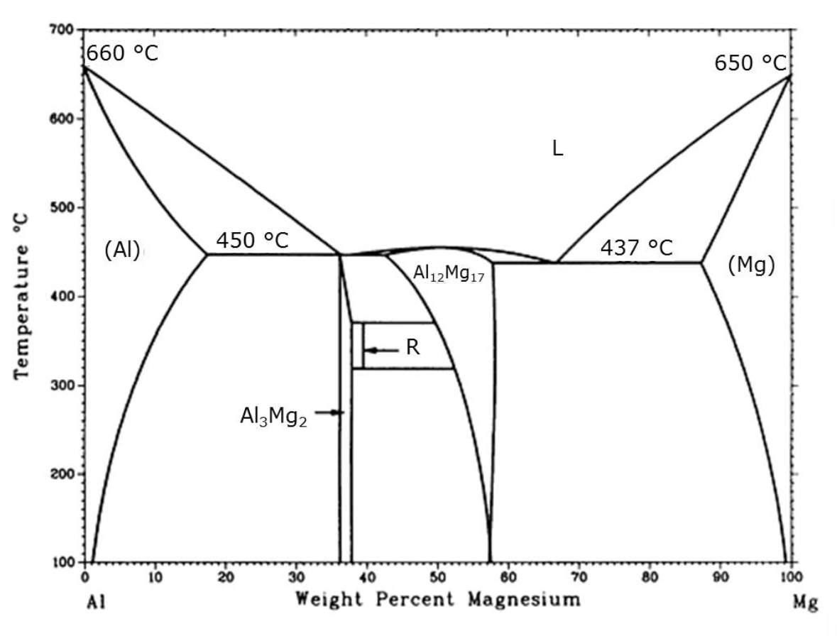

At which temperature starts solidification of an AlMg alloy with 10 wt.% Mg?

* at $450 °C$
* at $520 °C$
* **at $600 °C$**
* at $660 °C$

Question 2: A molten aluminium magnesium alloy containing 10 wt.% Mg is slowly cooled from 700 °C under conditions of thermal equilibrium. The figure shows the phase diagram of the binary system aluminium-magnesium (Al-Mg).



Which **solid** phase is formed first during **solidification** of an AlMg alloy with 10 wt.% Mg?

Liquid phase (L) on the right side of solidification point. Solid aluminium (Al) phase on the left side. Go horizontally to the left from the solidification point to find the wt.% of Magnesium in (Al) phase.

We get in blue that the solid phase formed is $(Al)$ with 4 wt.% Mg.

* **(Al) with 4 wt.% Mg**
* (Al) + L with 4 wt.% Mg
* (Al) with 10 wt.% Mg
* (Al) + L with 4 wt.% Mg

Question 3: A molten aluminium magnesium alloy containing 10 wt.% Mg is slowly cooled from 700 °C under conditions of thermal equilibrium. The figure shows the phase diagram of the binary system aluminium-magnesium (Al-Mg).

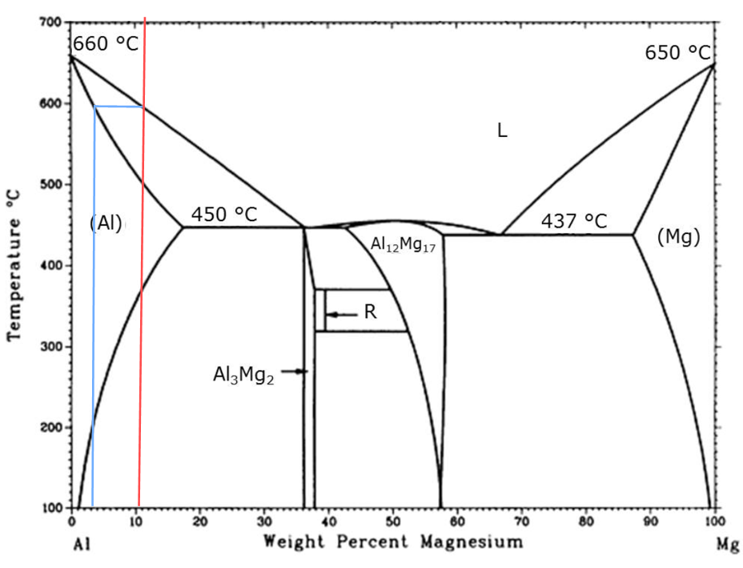

End of solidification

Start of solidification

What is the maximum magnesium content in the **melt** during solidification of an AlMg alloy with 10 wt.% Mg?

Liquid phase (L) on the right side of solidification point. Solid aluminium (Al) phase on the left side. Go horizontally to the right from the END of solidification point to find the maximum wt.% of Magnesium in (L) phase.

We get in blue that the highest possible magnesium wt.% in the melt (liquid phase L) is about 25 wt.%.

* exactly 10 wt.%
* **about 25 wt.%**
* about 36 wt.%
* above 36 wt.%

Question 4: A molten aluminium magnesium alloy containing 10 wt.% Mg is slowly cooled from 700 °C under conditions of thermal equilibrium. The figure shows the phase diagram of the binary system aluminium-magnesium (Al-Mg).



Two phases will be present after equilibrium cooling of an AlMg alloy to 100 C. One is Al3Mg2 with 36 wt.% Mg, what is the other phase?

(Al3Mg2) on the right side of 100 $°C$ point. Solid aluminium (Al) phase on the left side. Go horizontally to the left from 100 $°C$ point to find the wt.% of Magnesium in (Al) phase.

There is thus noticeably 1 wt.% Mg in (Al).

* **(Al) with 1 wt.% Mg**
* (Al) with 4 wt.% Mg
* (Al) with 10 wt.% Mg
* (Al) with 17 wt.% Mg

Question 5: A molten aluminium magnesium alloy containing 10 wt.% Mg is slowly cooled from 700 °C under conditions of thermal equilibrium. The figure shows the phase diagram of the binary system aluminium-magnesium (Al-Mg).



Least wt.% Mg in (Mg) point

What is the maximum solubility of aluminium in solid magnesium?

We read off the point of least wt.% Mg in (Mg) phase:

$$88 wt.\% Mg$$

Then, we compute the weight percentage of aluminium at that point:

$$100 wt.\%-88 wt.\% Mg=12 wt.\% Al$$

* about 1 wt.%
* **about 12 wt.%**
* about 88 wt.%
* about 99 wt.%

Question 6: The figure shows the phase diagram of the binary system titanium-nickel (Ti-Ni).

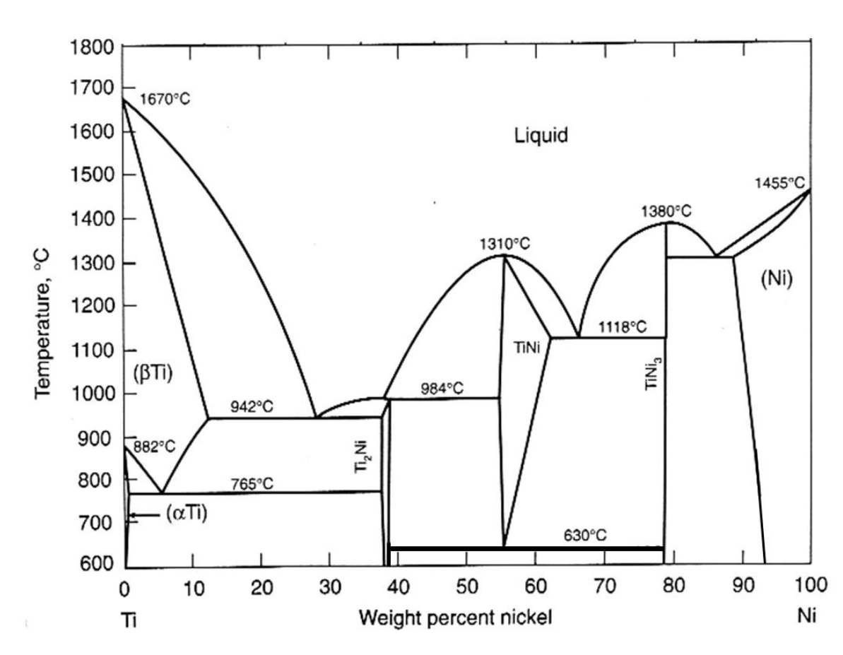

Point of max wt.% Ni in ($β$ Ti) or ($α$ Ti)

What is the maximum solubility of nickel in solid titanium?

We read off the point of most wt.% Ni in one of the two solid Titanium phases $(αTi)$ or $(βTi)$:

$$12 wt.\% Ni$$

* less than 1 wt.%
* about 5 wt.%
* **about 12 wt.%**
* about 88 wt.%

Question 7: The figure shows the phase diagram of the binary system titanium-nickel (Ti-Ni).

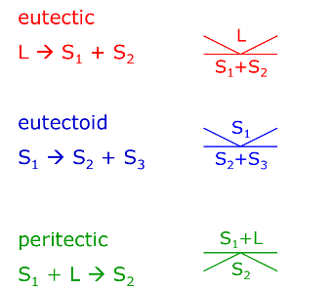

Eutectic points

Is there a eutectic point present in the phase diagram?

There are two. One at $(28 wt.\% Ni; 942 °C)$ and another at $(66 wt.\% Ni;118 °C)$.

* Yes, at $765 °C$ for $5 wt.\%$ Ni
* **Yes, at $1118 °C$ for $66 wt.\%$ Ni**
* Yes, at $1380 °C$ for $78 wt.\%$ Ni
* No, there is no eutectic point

Question 8: The figure shows the phase diagram of the binary system titanium-nickel (Ti-Ni).

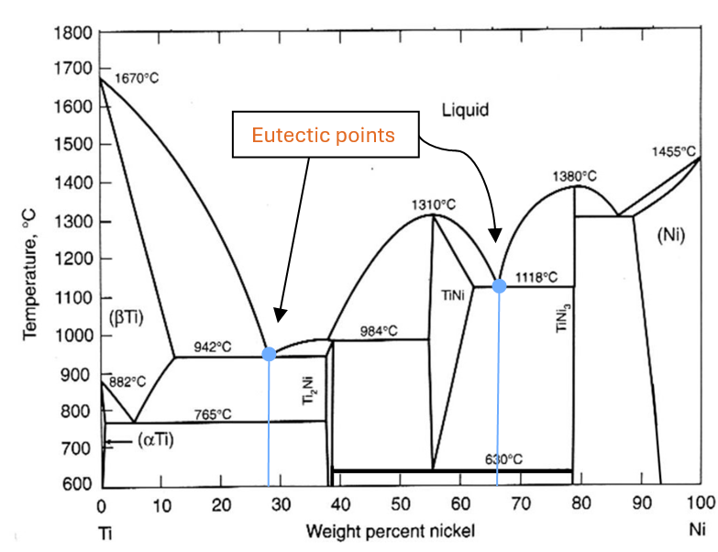

What is the lowest temperature, for which a melt of titanium and nickel can exist in thermal equilibrium?

Thermal equilibrium is obtained at the eutectic temperature. The lowest existing eutectic temperature for this phase diagram is clearly at $942 °C$.

$765 °C$

$942 °C$

$1118 °C$

$1310 °C$

Question 9: The figure shows the phase diagram of the binary system titanium-nickel (Ti-Ni).



Which phases exist at 800 °C for a titanium nickel alloy with 20 wt.% Ni in thermal equilibrium?

We look to the boundary left of the point $(βTi)$ and to the one right of the point $(Ti_{2}Ni)$. Two phases.

* One phase, $(βTi)$ + $Ti_{2}Ni$
* Two phases, $(αTi)$ and $Ti_{2}Ni$
* **Two phases, $(βTi)$ and $Ti_{2}Ni$**
* Three phases, $(αTi)$, $(βTi)$ and $Ti_{2}Ni$

Question 10: The figure shows the phase diagram of the binary system titanium-nickel (Ti-Ni).



How much nickel solid solution (Ni) does a specimen with mass 5 kg of a titanium nickel alloy with 82 wt.% Ni contain at 600 °C (in thermal equilibrium)?

$$W_{left}=\frac{c_{right}-c_{0}}{c_{right}-c_{left}}$$

$$W_{right}=\frac{c_{0}-c_{left}}{c_{right}-c_{left}}$$

We deem solid nickel solution phase (Ni) to be to the right, and $(TiNi_{3})$ phase to be to the left

$$c_{0}=82\%$$

$$c_{\left(TiNi_{3}\right)}=78\%$$

$$c_{(Ni)}=94\%$$

$$m=2,5 kg$$

$$W_{right}=\frac{c_{0}-c_{left}}{c_{right}-c_{left}}=W_{\left(Ni\right)}=\frac{c_{0}-c_{\left(TiNi_{3}\right)}}{c_{\left(Ni\right)}-c_{\left(TiNi_{3}\right)}}=\frac{82 \%-78 \%}{94 \%-78 \%}≈0,25$$

$$m_{right}=m_{\left(Ni\right)}=W_{\left(Ni\right)}·m=0,25·5 kg=1,25 kg$$

* 5 kg
* More than 2.5 kg
* **Less than 2.5 kg**
* None

Question 11: A molten aluminium manganese alloy containing 25 wt.% Mn is slowly cooled from 1300 °C under conditions of thermal equilibrium. The figure shows the phase diagram of the binary system aluminium-manganese (Al-Mn).

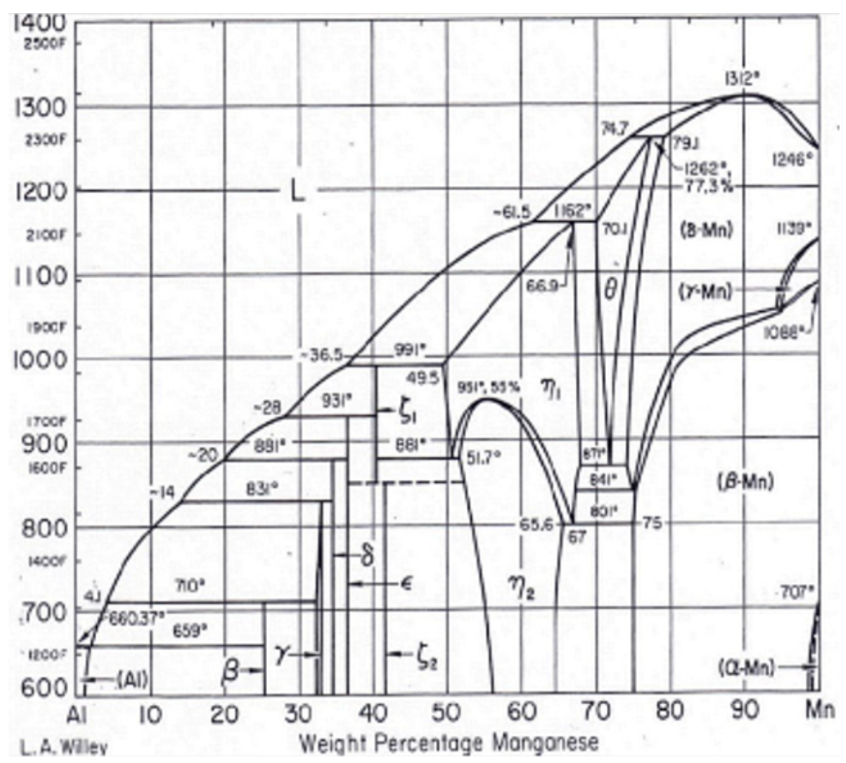

Which solid phase is formed first during the **solidification** of an AlMn alloy with 25 wt.% Mn?

We look to the horizontal sides of the solidification point. There’s liquid phase (L) to the left, but solid phase $(ϵ)$ to the right.

$γ$

$δ$

$ϵ$

$ξ_{1}$

Question 12: A molten aluminium manganese alloy containing 25 wt.% Mn is slowly cooled from 1300 °C under conditions of thermal equilibrium. The figure shows the phase diagram of the binary system aluminium-manganese (Al-Mn).



Which chemical composition has the **melt** at 800 °C during solidification of an AlMn alloy with 25 wt.% Mn?

From the point $(25 wt.\% Mn;800 °C)$ we look to the sides. There’s liquid melt phase (L) to the left and solid phase $(δ)$ to the right. We go all the way to the left, until we intersect the boundary there, and then we go down vertically and read off:

$$10 wt.\% Mn$$

which must mean

$$90 wt.\% Al$$

* **ca. 10 wt.% Mn and 90 wt.% Al**
* ca. 90 wt.% Mn and 10 wt.% Al
* still 25 wt.% Mn and 75 wt.% Al
* There is no melt left, everything is solified.

Question 13: A molten aluminium manganese alloy containing 25 wt.% Mn is slowly cooled from 1300 °C under conditions of thermal equilibrium. The figure shows the phase diagram of the binary system aluminium-manganese (Al-Mn).



Which is the dominating phase present at 600 °C during solidification of an AlMn alloy with 25 wt.% Mn?

We see that the ONLY phase there at $\left(25 wt.\% Mn;600°C\right)$ is $β$.

$(Al)$

$β$

$γ$

$\left(Al\right)+γ$

Question 14: A molten aluminium manganese alloy containing 25 wt.% Mn is slowly cooled from 1300 °C under conditions of thermal equilibrium. The figure shows the phase diagram of the binary system aluminium-manganese (Al-Mn).



Does an AlMn alloy with 25 wt.% Mn undergo peritectic transitions during cooling from 1300 °C to 600 °C?

There are three peritectic transitions. One at about $881 °C$, where it goes from $L+ϵ$ to $L+δ$. Another at $831 °C$ where it goes from $L+δ$ to $L+γ$. And a third at $700 °C$, where it goes from $γ+L$ to ONLY $β$. It’s apparently OK, that there’s still a melt component left after the transition.

* **Yes, the alloy undergoes in fact more than one peritectic transition.**
* Yes, the alloy undergoes exactly one peritectic transition.
* No, the alloy does not undergo any peritectic transition such transitions require a higher manganese content.
* No, the alloy does not undergo any peritectic transition, there is no such transition in the phase diagram.

Polymers and ceramics

Question 1: What is the molar mass of polyethylene?

Monomer: ${\left(C_{2}H_{4}\right)}_{n}$

$$M\left(C_{2}H_{4}\right)=2·12\frac{g}{mol}+4·1\frac{g}{mol} =28\frac{g}{mol}$$

$26 g/mol$

$28 g/mol$

$30 g/mol$

$32 g/mol$

Question 2: Which is the repeating unit of PVC?:

Monomer: ${\left(C_{2}H_{3}Cl\right)}_{n}$

* 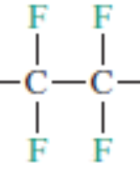
* 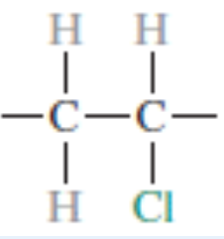 **(this is the repeating unit)**
* 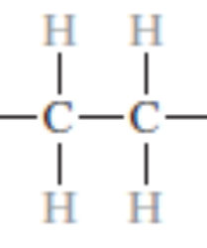
* 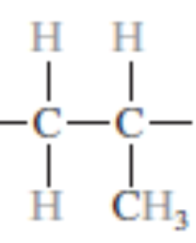

Question 3: What is the degree of polymerization of polypropylene with a (number-weighted) molar mass of 10 kg/mol?

Monomer: ${\left(C_{3}H_{6}\right)}_{n}$

Monomer molar mass $M\left(C_{3}H_{6}\right)=3·12\frac{g}{mol}+6·1\frac{g}{mol}=42\frac{g}{mol}$

Degree of polymerization $n=\frac{M}{M\left(C_{3}H_{6}\right)}=\frac{10 000\frac{g}{mol}}{42\frac{g}{mol}}≈238,0952≈200$

* About 25
* About 50
* About 100
* **About 200**

Question 4: The melting temperature of a polymer is lower, if…

* … the monomers have a larger molar mass.
* … cross bonds are present.
* … side bonds are present.
* **… side chains are present.**
* … the degree of polymerization is larger.

Question 5: Which statement about semi-crystalline polymers is correct?

* Their mass density is lower than that of an amorphous polymer of same composition.
* Their mass density is lower than that of a fully crystalline polymer of same composition.
* They are transparent.
* **They are opaque.**

Question 6: Thermosets cannot be remelted due to …

* … strong van der Waals bonds between polymer chains.
* … strong electron pair bonds along polymer chains.
* … strong hydrogen bonds between side groups.
* **… strong covalent cross bonds between polymer chains**

Question 7: Which crystal lattice is expected for cubic boron nitride BN? The table summarizes the properties of the elements.

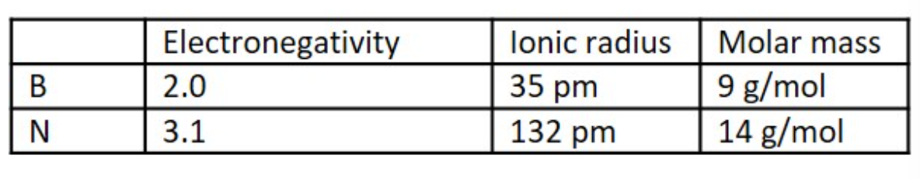

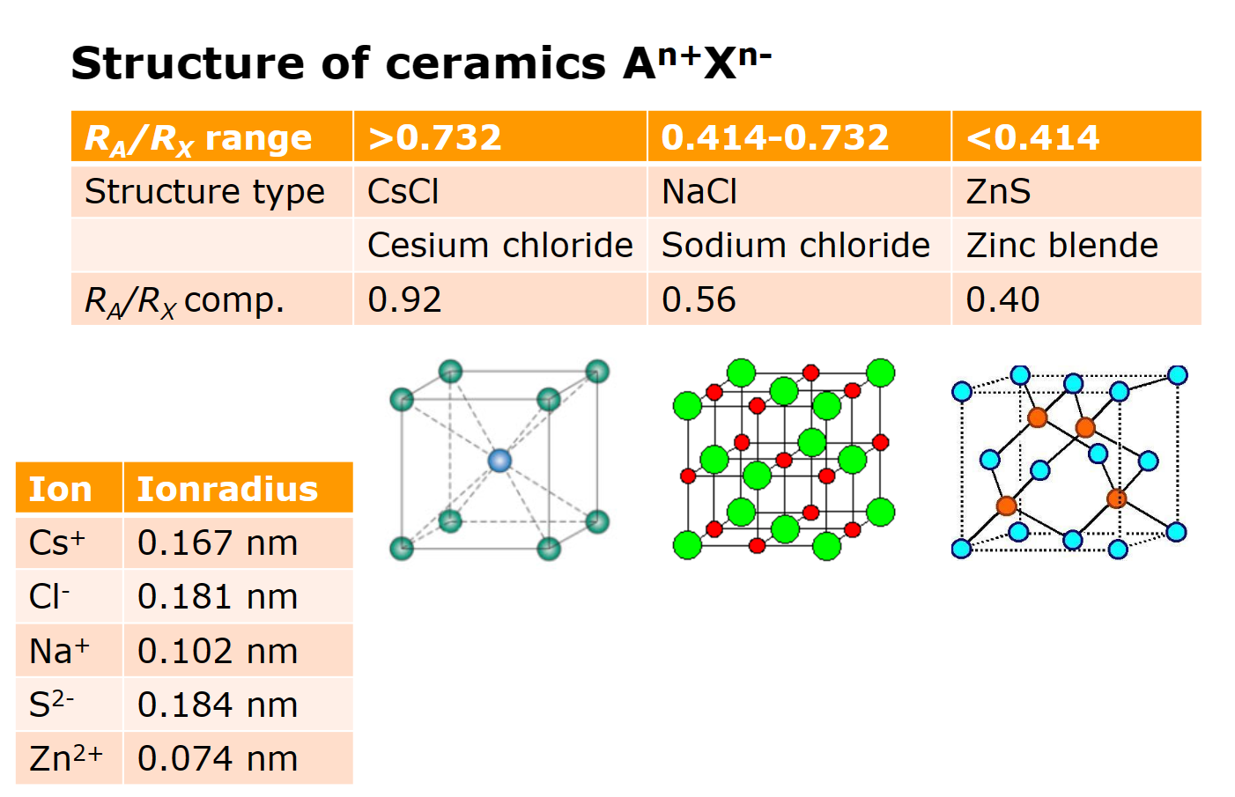

$$\frac{R_{A}}{R_{X}}=\frac{35 pm}{132 pm}≈0,2651515$$

* CsCl structure
* NaCl structure
* **ZnS structure**
* Diamond structure

Question 8: What is the fraction of ionic bonding in boron nitride? The table summarizes the properties of the elements.



$$f_{ion}=1-e^{\frac{-{\left(x_{A}-x_{B}\right)}^{2}}{4}}=f_{ion}=1-e^{\frac{-{\left(2,0-3,1\right)}^{2}}{4}}≈0,2610315≈25\%$$

* less than 15%
* **about 25%**
* about 75%
* higher than 85%

Question 9: What is the density of cubic titanium nitride TiN, which crystallizes in the rock salt structure? The table summarizes the properties of the elements.

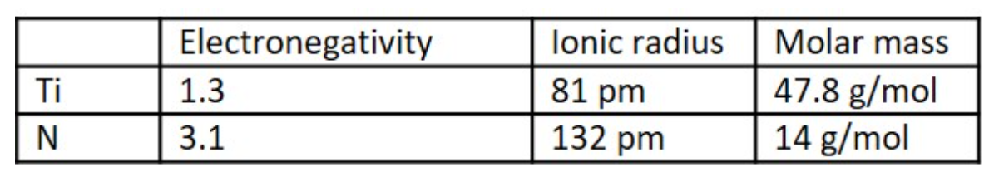

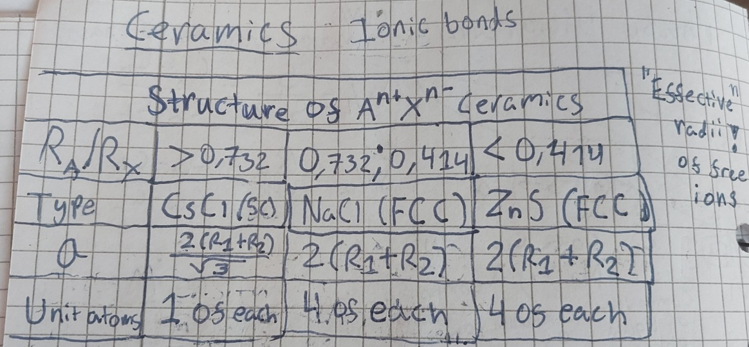

**BCC**

$$a=2·\left(R_{1}+R_{2}\right)=2·\left(81 pm+132 pm\right)=426 pm·{10}^{-10}\frac{cm}{pm}≈4,26·{10}^{-8} cm$$

Mass density of ceramic:

$$ρ=\frac{N_{1}m_{1}+N_{2}m_{2}}{N_{A}·a^{3}}=\frac{4·47,8\frac{g}{mol}+4·14\frac{g}{mol}}{6,022·{10}^{23} mol^{-1}·{\left(4,26·{10}^{-8} cm\right)}^{3}}≈5,309809\frac{g}{cm^{3}}$$

* below $5 g/cm^{3}$
* **between $5 g/cm^{3}$ and $6 g/cm^{3}$**
* between $6 g/cm^{3}$ and $7 g/cm^{3}$
* above $7 g/cm^{3}$

Question 10: Which defects can be found in amorphous ceramics?

Amorphous solids are generally very unorganized. Because they are “solid liquids”, they do not have the defects that crystalline solids have; Vacancies, dislocations, grain boundaries etc.

* Vacancies
* Dislocations
* Grain boundaries
* **None of the mentioned**